**3. Student Information Retrieval**

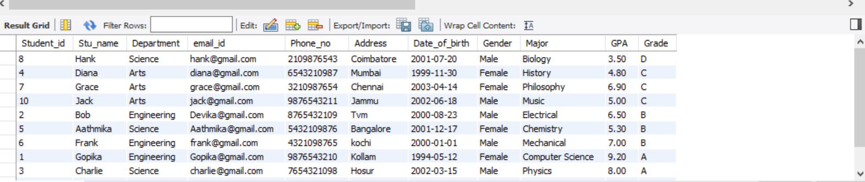

**4. Query for Male Students:**

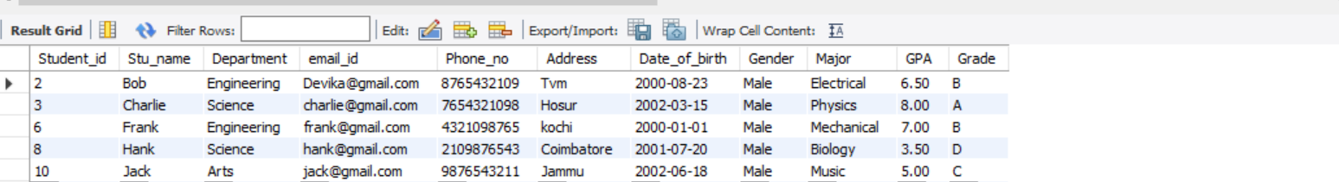

**5. Query for Students with GPA less than 5.0**



**7. Query for Students with Grade "B"**

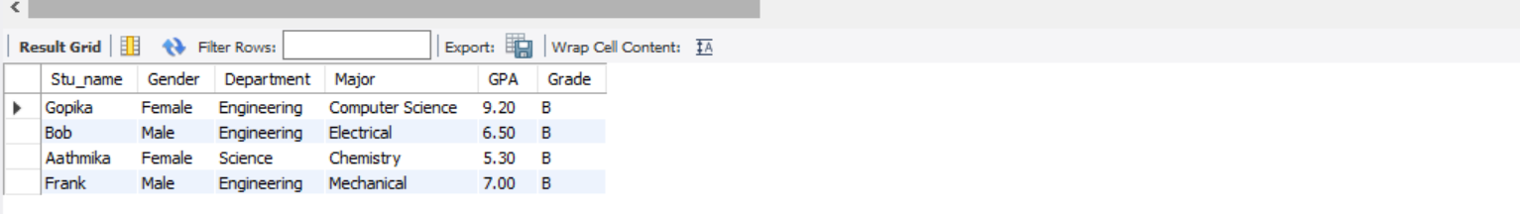

**8. Grouping and Calculation**

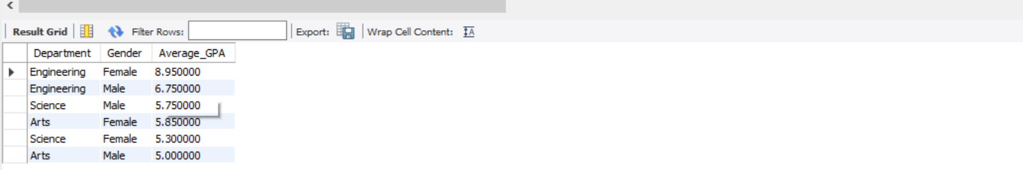

**10. Retrieve Student with Highest GPA**

